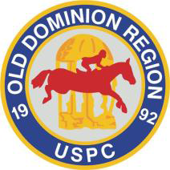
ODRPC Classified Ad Submission Form

Fill in this form to submit a classified ad for the Old Dominion Region website (olddominion.ponyclub.org).
Contact information:
Name: ___________________________________________________________
Club/Center member of: ____________________________________________
E-mail: ___________________________________________________________
Phone number: ____________________________________________________
Category you would like the ad to run in:
___ Horses/Ponies for Sale ___ Tack for Sale
___ Horses/Ponies for Lease ___ Trailers/Equipment for Sale
___ ISO Horses/Ponies ___ ISO Tack/Equipment
Wording for your ad (please make sure you include contact information):

Please email this form to the ODRPC webmaster at kechilders13@gmail.com.
You may also send up to 3 photos for your ad.
All ads are subject to approval by the ODRPC RS or VRS. This is a free service offered for ODRPC members and their immediate families only. Business ads or ads on behalf of others are not permitted.
The ad will run for up to 3 months. Please inform the webmaster if sold/found earlier so it can be removed. After 3 months, you may request renewal by emailing the ODRPC webmaster, or the ad will be removed.

